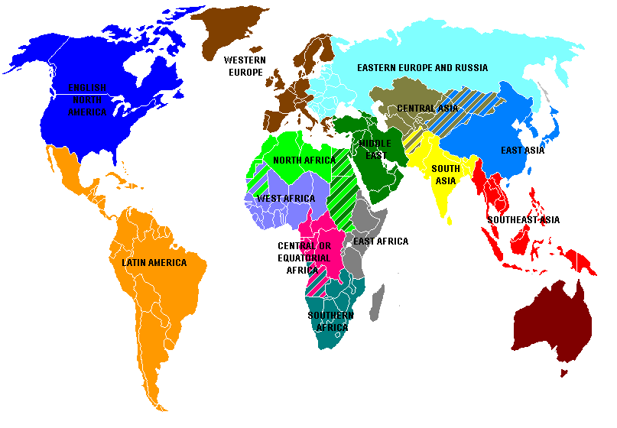AP WORLD HISTORY REGIONS

COUNTRIES OF THE CONTEMPORARY WORLD



